**Ebulliometric Determination of The Infinite**

**Dilution Activity Coefficient**

Name: Naimkhan Shaikh (22110239)

Group Members: Rutvi Shah, Shrey Agarwal

Table of Contents

Objective and Background

Procedure

Observation Table

Calculations and Calculation Table

Results and Discussion

Conclusion

**Objective and Background:**

**Aim**

1. To determine the value of the ‘Infinite Dilution Activity Coefficient’ (IDAC) of a binary mixture at 1 atm pressure using differential ebullometry and the limiting slope method.
2. To estimate the parameters in the activity coefficient correlations such as Van Laar / Wilson.

**Background**

Raoult's and Henry's laws describe ideal behaviour in solutions, where the concentration of a component and its vapour pressure are directly proportional to the component's mole fraction. However, real-world solutions often deviate from this ideal due to molecular interactions. Activity coefficients are introduced to account for these deviations from ideal behaviour. In an ideal solution, the activity coefficient of each component is 1, meaning that the component behaves according to Raoult's or Henry's laws. In real solutions, molecular interactions cause deviations from ideality, which are reflected by activity coefficients that differ from 1.

Consider a simple real-life example: mixing sugar into water. In an ideal solution, the concentration of sugar would be directly proportional to the amount added, and the total volume would be the sum of the sugar and water volumes. However, in reality, the interactions between water and sugar molecules affect the solution's behaviour. The volume may be less than expected because the molecules take up space and interact with each other. The activity coefficient helps explain these deviations and the limitations of dissolving sugar beyond a certain point.

The activity coefficient is a measure of how far a real solution diverges from ideal behaviour. When the activity coefficient equals 1, the solution follows Raoult's law exactly. In nonideal solutions, the activity coefficient differs from 1. The activity coefficient at infinite dilution, 𝛾∞, is particularly useful for understanding the behaviour of solvent molecules when they are in close contact with a single solute molecule.

The largest deviation from ideal solution behaviour occurs at infinite dilution, where one component is present in very small quantities. The activity coefficients at infinite dilution are, therefore, important indicators of how much the solution deviates from ideality. This knowledge is essential for performing phase equilibrium calculations, as these coefficients can be used to determine the parameters for the activity coefficient model that best represents the binary mixture.

By experimentally determining these infinite dilution activity coefficients (IDACs), we can better understand how solutions deviate from ideal behaviour.

**Procedure:**

* Take 100 ml of the solution (99 ml acetone + 1 ml benzene) and mix it thoroughly to ensure it's well-mixed.
* Fill the ebulliometer with 40 ml of the solution from the 100 ml mixture.
* Turn on all switches on the ebulliometer.
* Start gently heating the ebulliometer.
* Once the solution's temperature stabilizes, measure the rate at which bubbles rise in the ebulliometer. Be cautious not to touch the plug; it can pop out under pressure.
* Perform similar experiments using parallel-operating ebulliometers with pure acetone and a 98 ml acetone + 2 ml benzene solution.
* Repeat these steps for various steady-state temperatures.
* Plot a graph using the collected data points.
* Extrapolate the graph linearly to determine the bubble point temperature.
* Calculate the Infinite Dilution Activity Coefficient (IDAC) and Van Laar equation coefficients based on the experimentally determined values.

**Observation Tables:**

Component 1: Benzene

Component 2: Acetone

Antoine Coefficient:

|  |  |  |  |  |  |
| --- | --- | --- | --- | --- | --- |
| Component | A | B | C | $$\ln{P_{1}}$$ | $$P_{1}$$ |
| Benzene | 6.9 | 1211.03 | 220.79 | 2.873835566 | 17.70479605 |
| 6.9 | 1211.03 | 220.79 | 2.113130954 | 8.274106617 |
| 6.9 | 1211.03 | 220.79 | 2.516815665 | 12.38908279 |
| 6.9 | 1211.03 | 220.79 | 2.611498283 | 13.61944134 |
| 6.9 | 1211.03 | 220.79 | 2.245593605 | 9.446021095 |
| 6.9 | 1211.03 | 220.79 | 2.56234464 | 12.96618273 |
|  | A | B | C | $$\ln{P_{2}}$$ | $$P_{2}$$ |
| Acetone | 7.3 | 1277.03 | 237.23 | 3.274434953 | 26.42828802 |
| 7.3 | 1277.03 | 237.23 | 2.560253127 | 12.93909213 |
| 7.3 | 1277.03 | 237.23 | 2.9375158 | 18.86891388 |
| 7.3 | 1277.03 | 237.23 | 3.026566944 | 20.62629967 |
| 7.3 | 1277.03 | 237.23 | 2.683617106 | 14.63794465 |
| 7.3 | 1277.03 | 237.23 | 2.980309847 | 19.6939178 |

|  |  |  |  |  |  |  |
| --- | --- | --- | --- | --- | --- | --- |
| Benzene | Acetone |  |  |  |  |  |
| $$x_{1}$$ | $$x_{2}$$ | $$T\left(°C\right)$$ | Drops per min | Time (s) | $$\frac{dT}{dx_{1}}$$ | $$\frac{dT}{dx_{2}}$$ |
| 1 | 0 | 80 | 71 | 60 | 9.8 | -9.8 |
| 0.01 | 0.99 | 32.2 | 27 | 60 | 9.8 | -9.8 |
| 0.02 | 0.98 | 55.5 | 5 | 60 | 9.8 | -9.8 |
| 0 | 1 | 61.6 | 25 | 60 | 9.8 | -9.8 |
| 0.99 | 0.01 | 39.4 | 15 | 60 | 9.8 | -9.8 |
| 0.98 | 0.02 | 58.4 | 8 | 60 | 9.8 | -9.8 |

**Calculations:**

Antoine Equation:

$$log\left(P_{sat}\right)=A-\frac{B}{T+C}$$

$P_{1}=17.705 KPa$ and $P_{2}=20.626 KPa$.

$\frac{dP_{1}}{dt} = \frac{P_{1} ⋅ B}{{\left(T + C\right)}^{2}} =0.237$. Similarly, $\frac{dP_{2}}{dt} = \frac{P_{2} ⋅ B}{{\left(T + C\right)}^{2}} =0.295$.

Infinite Dilution Coefficient for Component 1:

$$γ_{1}^{∞}=\frac{P_{2}^{sat}- \left(\frac{ⅆP_{2}^{sat}}{dT}\right){\left(\frac{dT}{dx_{1}}\right)}_{P}^{∞}}{P_{1}^{sat}}$$

Putting in the values, we get $γ_{1}^{∞}=1.3285$. Similarly, $γ_{2}^{∞}= 0.746$.

Van Laar Coefficients:

$$a=1+\frac{x_{2}\ln{γ_{2}}}{x_{1}{\left(\ln{γ_{1}}\right)}^{2}}=$$

$$b=1+\frac{x_{1}\ln{γ_{1}}}{x_{2}{\left(\ln{γ_{2}}\right)}^{2}}$$

If $x_{1}$ and $x_{2}$ tend to infinity, then

$$a=\ln\left(γ_{1}^{∞}\right)=0.123$$

$$b=\ln\left(γ_{2}^{∞}\right)=-0.127$$

**Results and Discussion:**

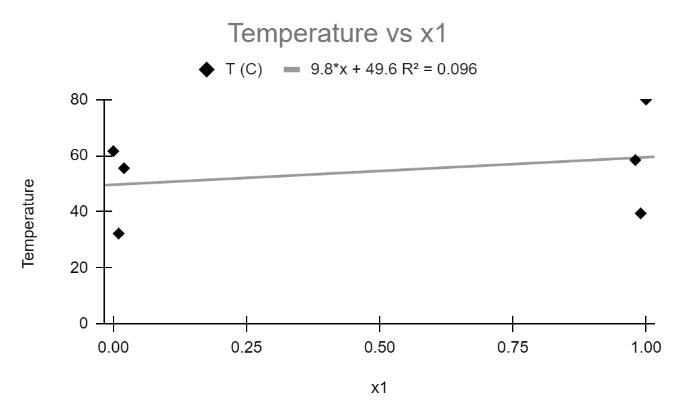

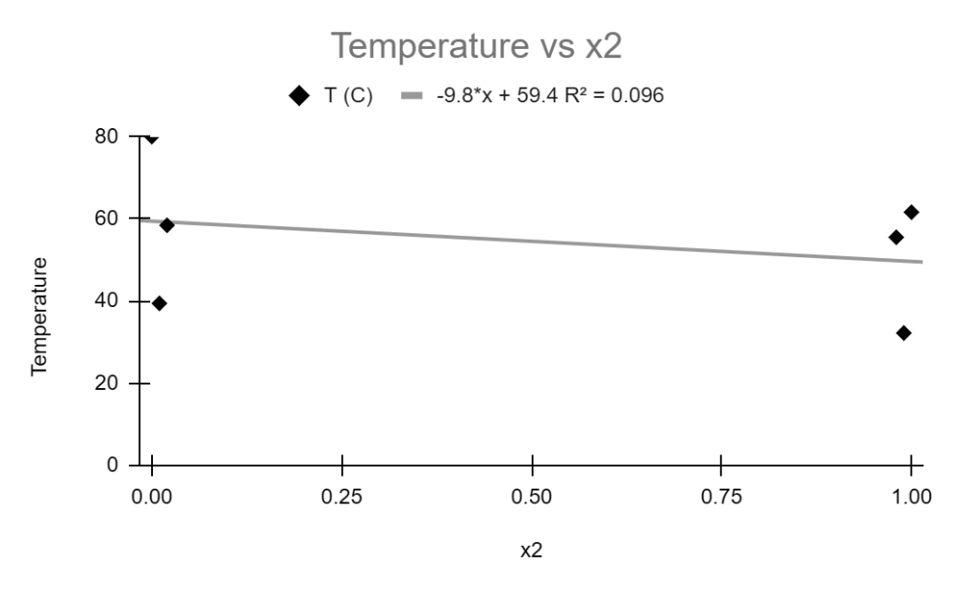

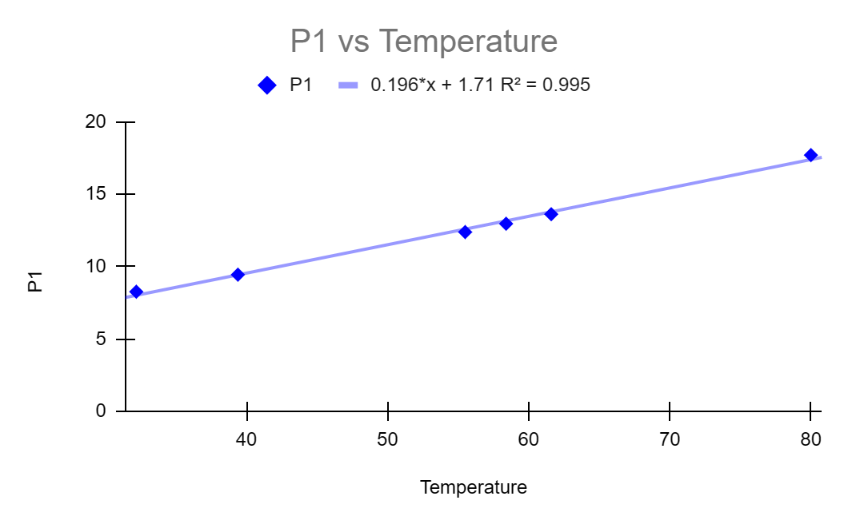

**Conclusion:**

1. Drop Rate Increases with Time: The data shows that the rate of liquid drops per minute increases as time progresses, indicating that more liquid evaporates over time. This is consistent with the expectation that as the solution heats up, more molecules gain sufficient kinetic energy to escape the liquid phase, increasing the vaporisation rate.
2. Effect of Temperature on Vaporization: As the temperature increases, more liquid boils off. This is reflected in the data by the increasing vapour pressures (P1 and P2) and higher values of the ln P1 and ln P2 at higher temperatures. This indicates that vaporisation becomes more rapid as the temperature approaches the boiling points of benzene (80°C) and acetone (61.6°C).
3. Boiling Points and Mole Fraction: The boiling point of a mixture can be determined by plotting temperature against mole fraction (x1 for benzene and x2 for acetone). The data suggests that as the mole fraction of one component increases (e.g., x1 for benzene), the boiling point adjusts accordingly. For instance, at x1 = 0.99, the temperature is 39.4°C, indicating a significant deviation from the pure component boiling points due to non-ideal behaviour.
4. Activity Coefficients: The activity coefficients (γ1 and γ2) indicate non-ideal behaviour in the mixture. For example, for pure benzene (x1 = 1), γ1 is 1.337, whereas for pure acetone (x2 = 1), γ2 is 0.753. These deviations from unity suggest significant interactions between benzene and acetone molecules that affect their vapor pressures.
5. Van Laar Coefficients (a and b): The Van Laar coefficients (a and b) show how the components deviate from ideality. The negative values of the coefficients suggest attractive forces between the components, particularly for acetone (b = -0.127), where the interactions between acetone molecules may be weaker compared to those between benzene molecules.
6. $\frac{dP}{dT}$ Behaviour: The values of $\frac{dP_{1}}{dT}$ and $\frac{dP_{2}}{dT}$ (the rate of change of vapour pressure with temperature) indicate how sensitive each component's vapour pressure is to temperature changes. Higher values reflect a steeper increase in vapour pressure with temperature, contributing to faster boiling.

Industries such as petrochemicals, pharmaceuticals, and food processing rely on phase equilibrium calculations involving activity coefficients, particularly when designing distillation, extraction, or crystallisation processes. These industries need accurate data on how components interact in mixtures, especially under non-ideal conditions.

In academia and research, these principles are used in:

* Developing new thermodynamic models for complex mixtures.
* Studying molecular interactions and their effects on solution properties.
* Improving computational methods for predicting solution behaviour.
* Designing novel separation techniques and reactive systems.

Additional Parameters to Test:

* Temperature dependence: To understand how activity coefficients change with temperature.
* Salt effects: To study how electrolytes influence activity coefficients.
* Mixture complexity: Investigating activity coefficients in multi-component systems to reflect real-world scenarios better.
* Surface tension and interfacial properties: To understand how activity coefficients relate to these physical properties.

**References:**

* <https://link.springer.com/referenceworkentry/10.1007/978-981-10-6739-6_115-1#:~:text=The%20infinite%20dilution%20activity%20coefficient%20of%20compounds%20in%20ionic%20liquids,the%20separation%20performance%20of%20ILs>.
* Lab Manual